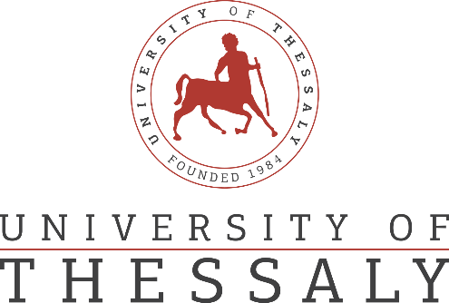

PRESS RELEASE OF

MEDICAL EQUIPMENT DONATION FROM CENTRAL UNIVERSITY OF FINANCE AND ECONOMICS TO THE UNIVERSITY OF THESSALY

Significant donation of medical supplies to the University of Thessaly, for the protection of the medical and nursing staff of the University General Hospital of Larissa against the Covid-19 virus, was offered from the Central University of Finance and Economics (CUFE), the CUFE Education Foundation and the CUFE Alumni Association.
The donation, which was received from the Dean of the Department of Medicine of the University of Thessaly, Professor Athanasios Giannoukas, the Governor of the University Hospital of Larissa, Mr. Dimitrios Katsikonouris and the Deputy Governor and Vice President of the Board of Directors of the University General Hospital of Larissa, Mr. Georgios Apostolinas, concerns special protection masks type KN95 / N95 and protective gloves.
This is a direct import of medical equipment from China, thanks to the coordinated cooperation between the University of Thessaly and the Central University of Finance and Economics, and despite the difficulties of the project due to increased demand and shortages of health equipment internationally.
The Rector of the University of Thessaly, Professor Zisis Mamouris, the Dean of the Department of Medicine, Professor Athanasios Giannoukas, the Governor of the University Hospital of Larissa, Mr. Dimitrios Katsikonouris, as well as all the staff of the University Hospital, extend their warm thanks to CUFE, CUFE Education Association and CUFE Alumni Association for this extremely beautiful gesture in these difficult times.

