PRESS RELEASE

Consortium meeting of project ICT-INOV in Ho Chi Minh City, Vietnam

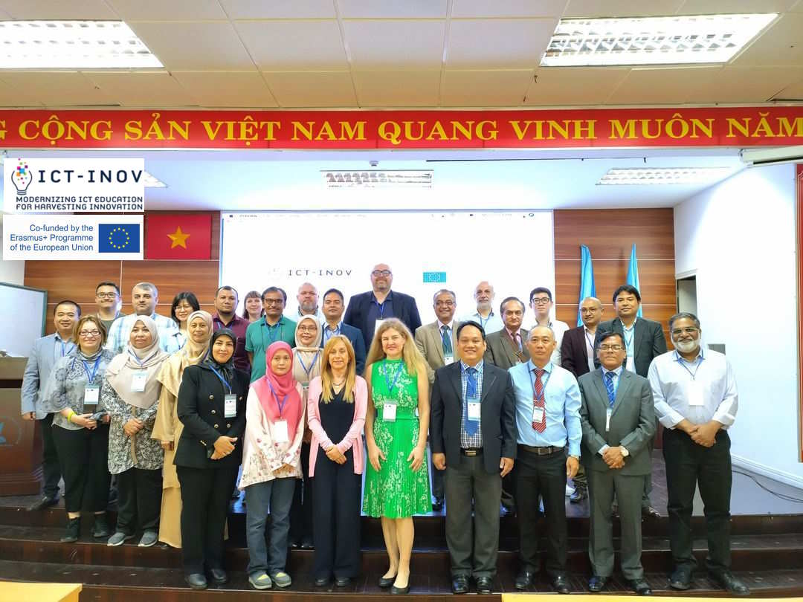
The Department of Electrical and Computer Engineering of the University of Thessaly, and specifically the Creative Technologies Learning Lab research team (http://ctll.e-ce.uth.gr), participated in the 4th scheduled consortium meeting of project ICT-INOV: Modernizing Higher Education for Harvesting Innovation funded by the Capacity Building in Higher Education action of the Erasmus+ program of the European Commission. The research project aims to introduce digital learning interventions to develop innovation skills in Computer Science and Computer Engineering students.
Project ICT-INOV is implemented by a consortium of 12 universities from Greece, Portugal, Estonia, Italy, Malaysia, Nepal, Pakistan, and Vietnam. The project aims to transfer know-how between universities in Asia and Europe on deploying design thinking, a deeply human-centered process of introducing solutions to entrepreneurship and social entrepreneurship challenges with the aim of strengthening students' ability to turn ideas into action. The research project develops digital infrastructures in the form of laboratories, digital collaboration services, digital learning activities for innovation. The project further builds the capacity of educators to design and deploy in the classroom design thinking inspired activities through instructor training and community building events.
The consortium meeting took place in Ho Chi Minh City, Vietnam from 3 to 5 April 2023 and was organized by Vietnam National University Ho Chi Minh City. Thirty researchers participated. Participants had the opportunity to collaborate on all actions of the research project, such as the development of digital infrastructure, the design and development of digital learning innovation services, the development of learning activities, the piloting of the proposed solution, and the development of good practices for the promotion of innovative thinking.

