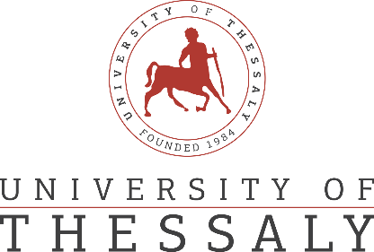

**PRESS RELEASE**

“HERMES Team: The innovative robotics research group

of the University of Thessaly”

The **HERMES Team** of the University of Thessaly pioneers the development of robotic exoskeletons for medical applications, aiming at **CYBATHLON 2024**!

**HERMES Team** represents the largest student research group in robotics for medical applications in Greece and operates under the auspices of the University of Thessaly (UTH). Specifically, **HERMES Team** is engaged in the development of a fully functional robotic exoskeleton for individuals with Spinal Cord Injuries (SCI), providing them with the capability to fulfill basic daily needs. Its objective is to participate in the international competition **CYBATHLON 2024** in the “Exoskeleton Race” discipline, marking the first Greek participation. With the support of the Department of Electrical & Computer Engineering at UTH, HERMES Team is dynamically progressing towards improvement and technological development.

More Information: <https://linktr.ee/hermesteam>