Innovation activities at the Department of Electrical and Computer Engineering, University of Thessaly
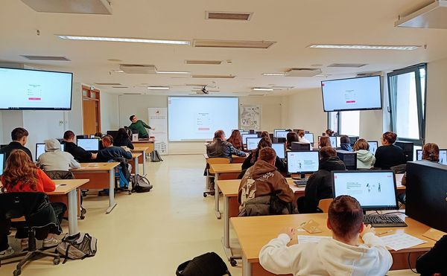
The Department of Electrical and Computer Engineering of the University of Thessaly (DECE), specifically the Creative Technologies Learning Lab (http://ctll.e-ce.uth.gr ) research group, organised educational activities to design innovative solutions that apply digital technology to sustainability. The action took place in DECE's computer laboratory. The 3rd High School of Nea Ionia, Volos and the Public Institute of Vocational Training (SAEK) of Volos participated in the event and visited DECE on separate occasions, on October 23 and 24, respectively. A total of 24 students from the 5th Lyceum of Volos participated in the event, and they were accompanied by their educator Mr. Pantazis Fasoulidis.
Εικόνα 1. Το 5^{ο} Λύκειο Βόλου στο ΤΗΜΜΥ.
Students participated in experiential workshops for innovation, which profoundly impacted their learning. Tailored to each group's interests, knowledge, and skills, they applied design thinking, a profoundly human-centred methodology of synthesising solutions to complex challenges of entrepreneurship and social entrepreneurship, to introduce solutions related to the United Nations Sustainability Goals. Through exploration, ideation, and synthesis, they presented creative ideas to address broad sustainability challenges, such as managing plastics, clean energy, responsible natural resources management such as forests, and more.
The action occurred within the framework of the research project eDea (http://eDea-project.gr ), funded by the Research—Create—Innovate Greece 2.0 program. The project aims to design digital services and content to promote innovation. It will be implemented from 2021 to 2025 with the participation of the University of Thessaly, the University of the Aegean, and the companies Design4Future and Butlair. The scientific coordinator of the project is DECE Pr. Elias Houstis. DECE researcher Dr. Hariklia Tsalapatas coordinated the activities.

